  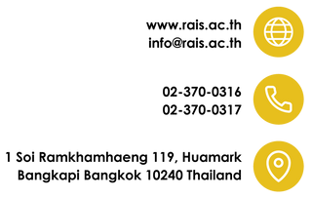

**AP TEST PARTICIPATION FORM FOR NON- RAIS /HOME- SCHOOLED STUDENTS**

|  |  |  |  |  |  |
| --- | --- | --- | --- | --- | --- |
| Full Name |  | | | Nickname |  |
| Grade |  | Student ID# |  | Birthdate |  |
| Mobile No. |  | LINE ID |  | Email |  |
| Current School |  | | | | |

|  |
| --- |
| **Exam(s) Requested:** |
| 1. |
| 2. |
| 3. |
| 4. |
| 5. |
| 6. |

**Exam Cost & Deadline**

AP exam costs **7,500** per subject, which to be paid before **OCTOBER 31, 2023**After the due date a late fee of **3,000 Baht** per subject to be paid along with the regular fee before **February 29, 2024**.

|  |  |
| --- | --- |
| **Methods of Payment** | |
|  | Bank Name : **Ramkhamhaeng Advent International School**  Bank Account : **Bangkok Bank 056-0-52535-4** |

|  |  |
| --- | --- |
| **AP Coordinator** | |
|  | AP Coordinator : **Mr. Anand Rao Manduri**  [*mr.anand@rais.ac.th*](mailto:mr.anand@rais.ac.th) |

**Notes:**

If you are taking an exam that allows calculators, be certain that you bring an approved calculator to the exam room. It is the student's responsibility to follow the College Board's calculator policy.

I understand that the exam fees must be **paid in advance**. No exams will be ordered unless **paid in full**. A receipt must be presented to the AP coordinator. **There is no refund**.

|  |  |  |  |  |  |
| --- | --- | --- | --- | --- | --- |
| Student |  | Signature |  | Date |  |

|  |  |  |  |  |  |
| --- | --- | --- | --- | --- | --- |
| Parent |  | Signature |  | Date |  |

**FOR OFFICE USE ONLY:**

|  |  |  |  |
| --- | --- | --- | --- |
| Finance |  | Registrar |  |

FM-OF-RG-17 REV.NO. 2 DATE 1/10/2023